J7 Sports Activity 3

Find The Coaches

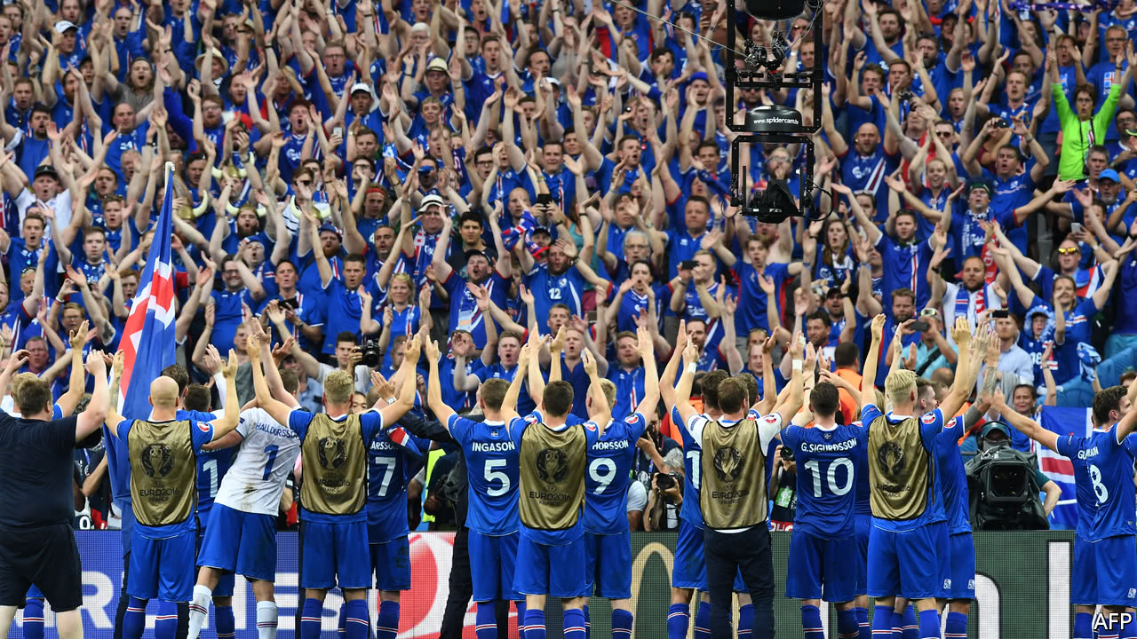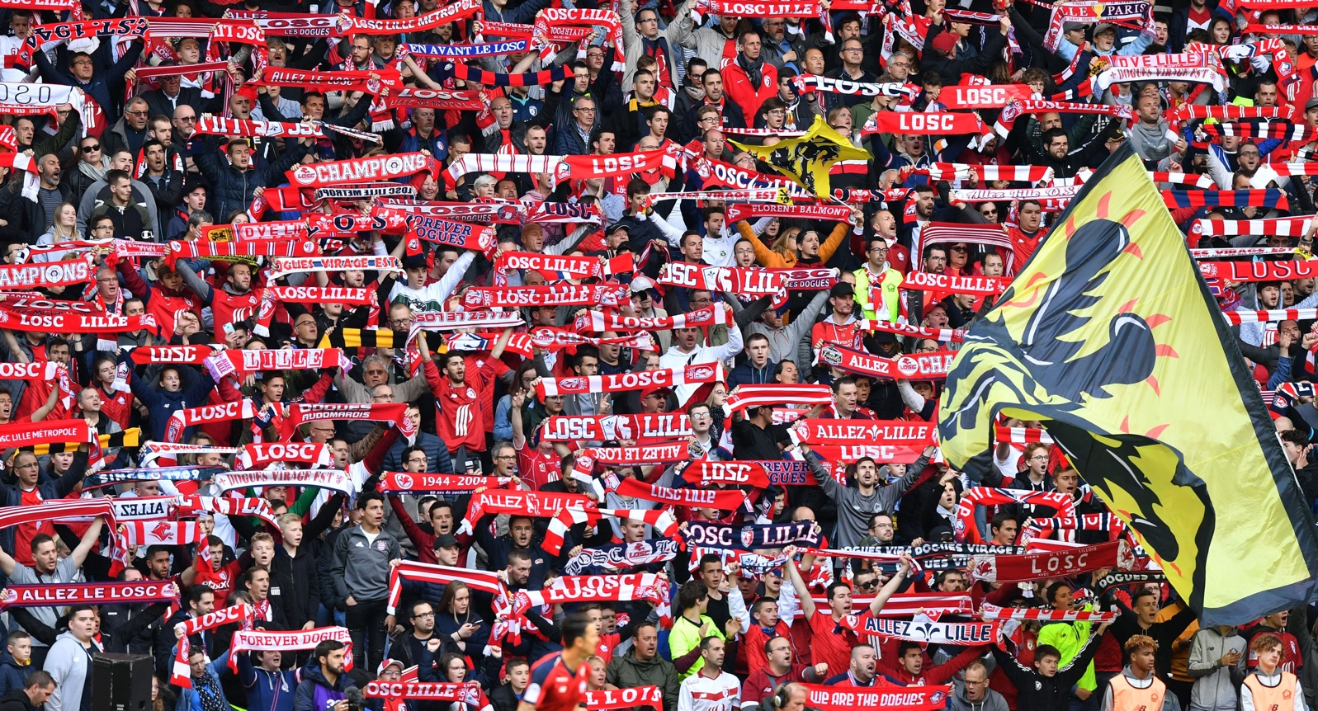If you can’t print, you could place the shapes between the pictures over each coach. You need to find Jamie, Steve, Matty and Archie.



