J7 Sports Activity 6

Where in the World?

The coaches have been on their travels and visited their favourite place in each continent.

Use the pictures and the clues to help find out where they are. Good luck.

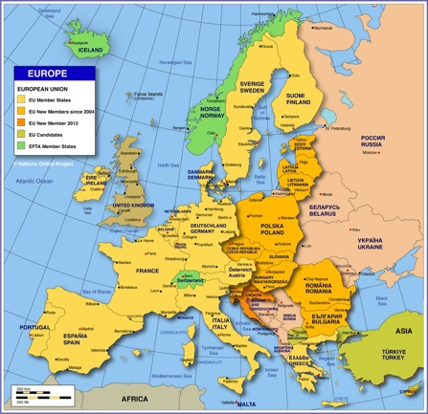

Continent 1: Europe.

* It was built as a royal palace and a defence system.
* It was designated as a World Heritage site by UNESCO
* 'If the ravens leave the site, the Kingdom will fall…'
* There are over 23,500 jewels there today.
* 22 executions took place here.
* It’s a very haunted location!

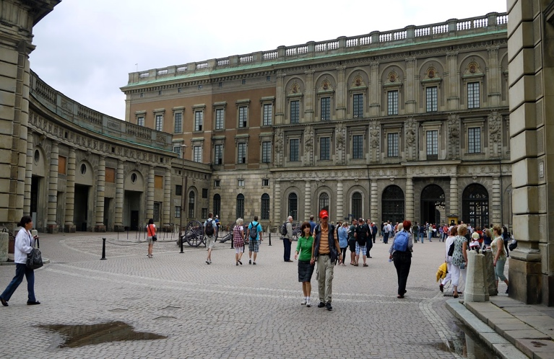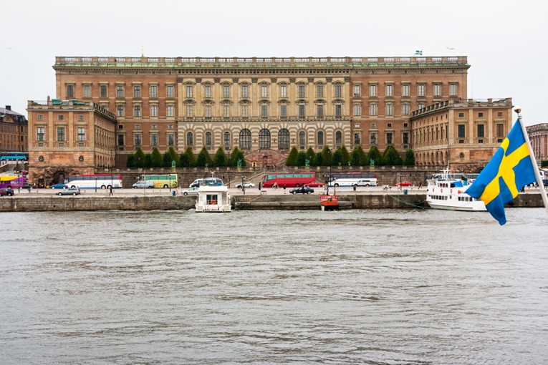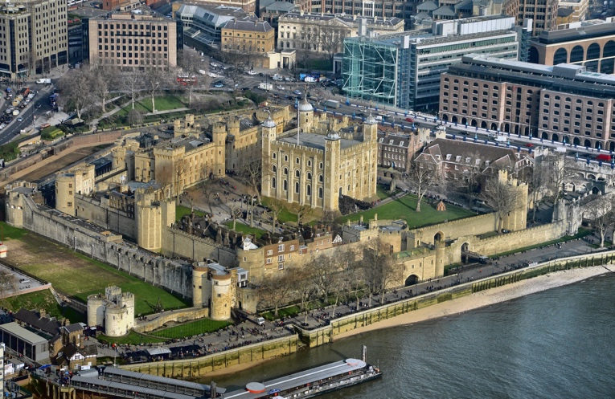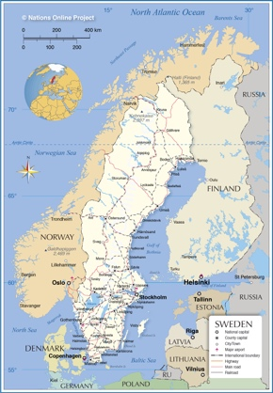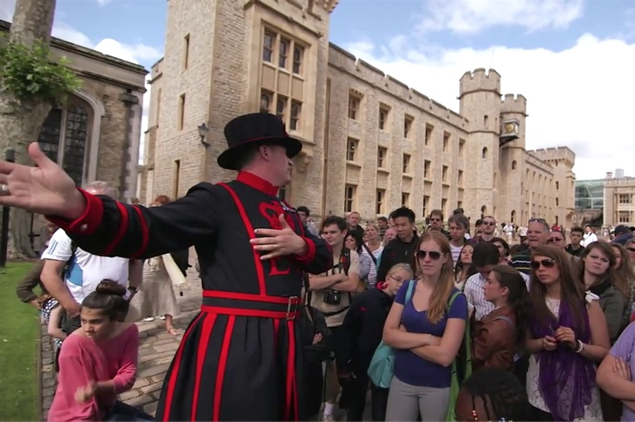

ANSWER:

ANSWER:

Continent 2: Scandinavia

* It is a royal castle located in Sweden
* It was built in the 18th century, after a fire in 1697 destroyed the old castle.
* The palace consists of 1,430 rooms and 660 windows and to this day is an impressive building.
* The palace is mainly built of brick and some sections are covered with sandstone.

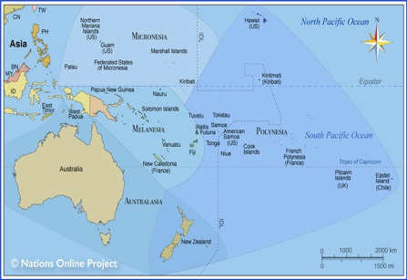

Continent 3: Oceania/Australasia

* It is a multi-venue performing arts centre.
* It is one of the 20th century’s most famous and distinctive buildings.
* Construction was expected to take four years. It took 14 years.
* Work commenced in 1959 and involved 10,000 workers.
* The original cost estimate to build it was $7 million. The final cost was $102 million.
* More than 10.9 million people visit here every year.
* It is cooled using seawater taken directly from the harbour.

ANSWER:

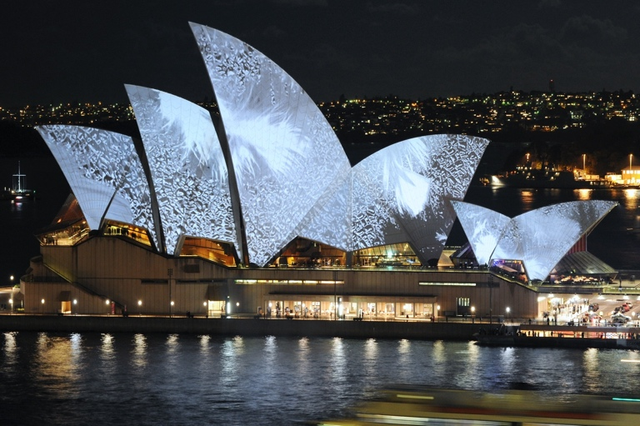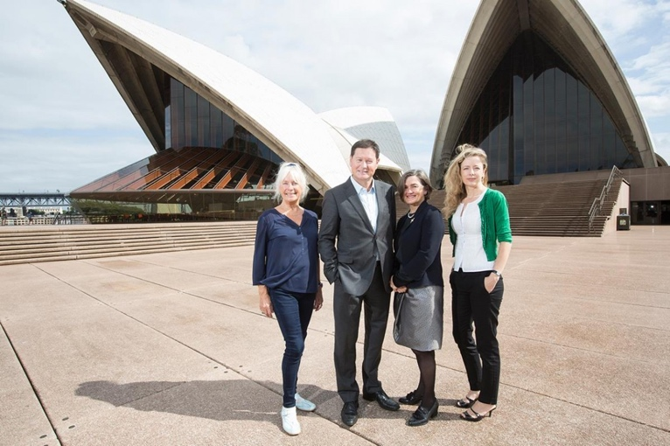

Continent 4: Asia

* It is a famous mausoleum in India (a building that contains burial chambers (tombs) for the deceased)
* It is located in Agra, a city in northern India.
* It was built as the final resting place for Mumtaz Mahal, the third wife of Mughal emperor Shah Jahan.
* The name means “crown of palaces”.
* Construction took around 20 years, beginning around 1632 and finishing around 1653.
* It attracts 7-8 million visitors a year.

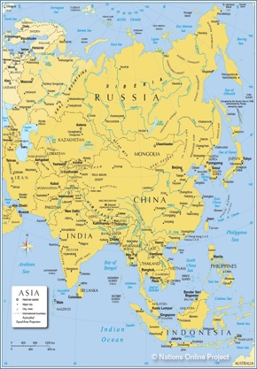

ANSWER:

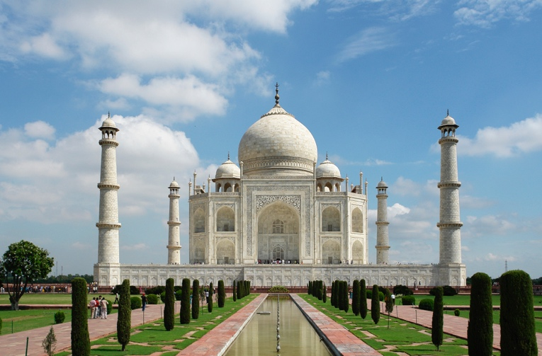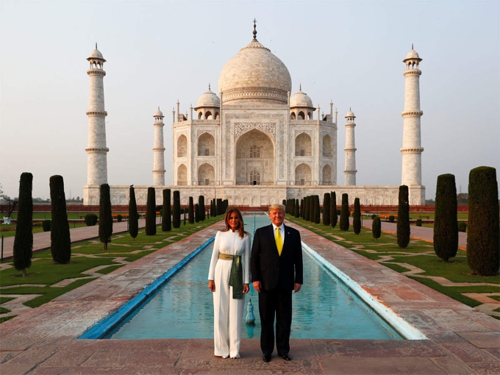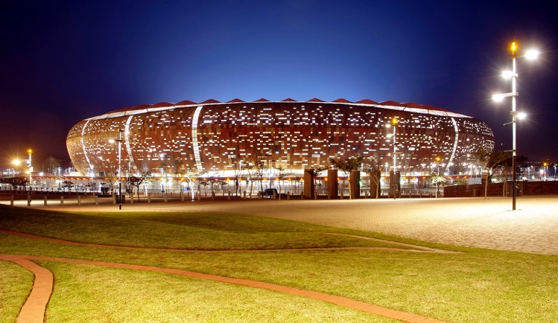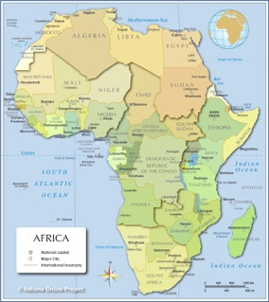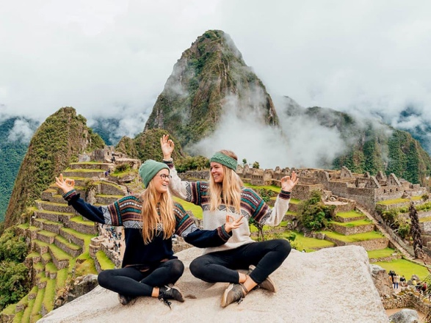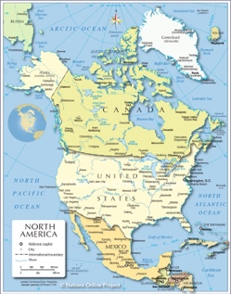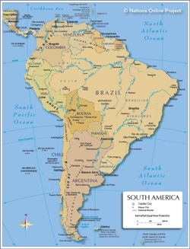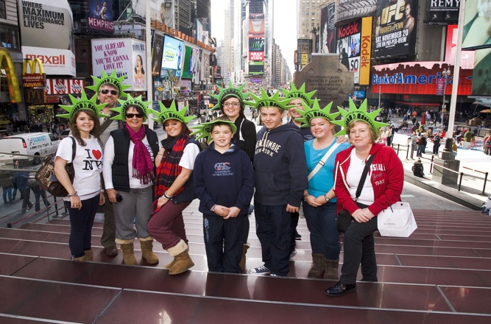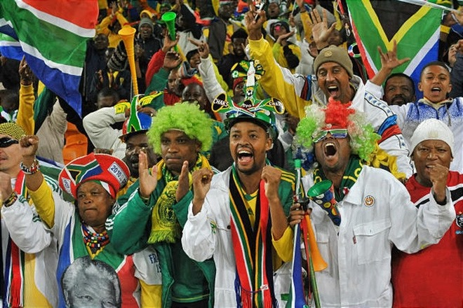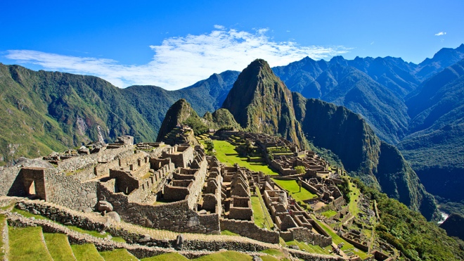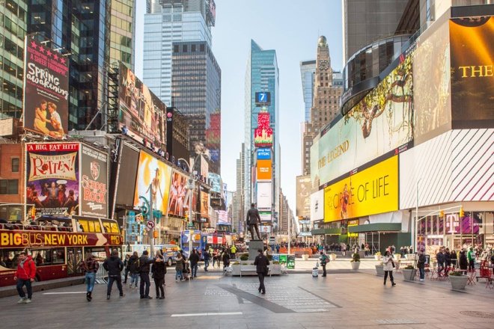

ANSWER:

ANSWER:

ANSWER:

Continent 6: South America

* It is an abandoned stone city built by the Incas, who were the largest civilisation in South America around 600 years ago. It was only discovered in 1911.
* It is classed as a New Wonder of the World.
* The name means ‘old mountain’.

Continent 7: Africa

* Is a sports stadium that was built in 1987, but was improved in 2009 ready to host the 2010 FIFA World Cup. It hosted the final.
* Has a capacity of around 94,000.
* It is used to host concerts, with Ed Sheeran, Coldplay, One Direction, Justin Bieber being amongst the people who have performed there.

Continent 5: North America

* It is a major commercial intersection, tourist destination, entertainment centre and neighbourhood, is one of the world's busiest pedestrian areas, and is sometimes referred to as "The Centre of the Universe".
* It is one of the world's most visited tourist attractions, drawing an estimated 50 million visitors annually.